What Is the CIA Triad?

The three letters in "CIA triad" stand for Confidentiality, Integrity, and Availability. The CIA triad is a common model that forms the basis for the development of security systems. They are used for finding vulnerabilities and methods for creating solutions.
The confidentiality, integrity, and availability of information is crucial to the operation of a business, and the CIA triad segments these three ideas into separate focal points. This differentiation is helpful because it helps guide security teams as they pinpoint the different ways in which they can address each concern.
Ideally, when all three standards have been met, the security profile of the organization is stronger and better equipped to handle threat incidents.

3 Core Components Of CIA Triad & Their Examples

1. Confidentiality
Confidentiality involves the efforts of an organization to make sure data is kept secret or private. To accomplish this, access to information must be controlled to prevent the unauthorized sharing of data—whether intentional or accidental. A key component of maintaining confidentiality is making sure that people without proper authorization are prevented from accessing assets important to your business. Conversely, an effective system also ensures that those who need to have access have the necessary privileges.
For example, those who work with an organization’s finances should be able to access the spreadsheets, bank accounts, and other information related to the flow of money. However, the vast majority of other employees—and perhaps even certain executives—may not be granted access. To ensure these policies are followed, stringent restrictions have to be in place to limit who can see what.
There are several ways confidentiality can be compromised. This may involve direct attacks aimed at gaining access to systems the attacker does not have the rights to see. It can also involve an attacker making a direct attempt to infiltrate an application or database so they can take data or alter it.
These direct attacks may use techniques such as man-in-the-middle (MITM) attacks, where an attacker positions themselves in the stream of information to intercept data and then either steal or alter it. Some attackers engage in other types of network spying to gain access to credentials. In some cases, the attacker will try to gain more system privileges to obtain the next level of clearance.
However, not all violations of confidentiality are intentional. Human error or insufficient security controls may be to blame as well. For example, someone may fail to protect their password—either to a workstation or to log in to a restricted area. Users may share their credentials with someone else, or they may allow someone to see their login while they enter it. In other situations, a user may not properly encrypt a communication, allowing an attacker to intercept their information. Also, a thief may steal hardware, whether an entire computer or a device used in the login process and use it to access confidential information.
To fight against confidentiality breaches, you can classify and label restricted data, enable access control policies, encrypt data, and use multi-factor authentication (MFA) systems. It is also advisable to ensure that all in the organization have the training and knowledge they need to recognize the dangers and avoid them.

2. Integrity
Integrity involves making sure your data is trustworthy and free from tampering. The integrity of your data is maintained only if the data is authentic, accurate, and reliable.
For example, if your company provides information about senior managers on your website, this information needs to have integrity. If it is inaccurate, those visiting the website for information may feel your organization is not trustworthy. Someone with a vested interest in damaging the reputation of your organization may try to hack your website and alter the descriptions, photographs, or titles of the executives to hurt their reputation or that of the company as a whole.
Compromising integrity is often done intentionally. An attacker may bypass an intrusion detection system (IDS), change file configurations to allow unauthorized access, or alter the logs kept by the system to hide the attack. Integrity may also be violated by accident. Someone may accidentally enter the wrong code or make another kind of careless mistake. Also, if the company’s security policies, protections, and procedures are inadequate, integrity can be violated without any one person in the organization accountable for the blame.
To protect the integrity of your data, you can use hashing, encryption, digital certificates, or digital signatures. For websites, you can employ trustworthy certificate authorities (CAs) that verify the authenticity of your website so visitors know they are getting the site they intended to visit.
A method for verifying integrity is non-repudiation, which refers to when something cannot be repudiated or denied. For example, if employees in your company use digital signatures when sending emails, the fact that the email came from them cannot be denied. Also, the recipient cannot deny that they received the email from the sender.

3. Availability
Even if data is kept confidential and its integrity maintained, it is often useless unless it is available to those in the organization and the customers they serve. This means that systems, networks, and applications must be functioning as they should and when they should. Also, individuals with access to specific information must be able to consume it when they need to, and getting to the data should not take an inordinate amount of time.
If, for example, there is a power outage and there is no disaster recovery system in place to help users regain access to critical systems, availability will be compromised. Also, a natural disaster like a flood or even a severe snowstorm may prevent users from getting to the office, which can interrupt the availability of their workstations and other devices that provide business-critical information or applications. Availability can also be compromised through deliberate acts of sabotage, such as the use of denial-of-service (DoS) attacks or ransomware.
To ensure availability, organizations can use redundant networks, servers, and applications. These can be programmed to become available when the primary system has been disrupted or broken. You can also enhance availability by staying on top of upgrades to software packages and security systems. In this way, you make it less likely for an application to malfunction or for a relatively new threat to infiltrate your system. Backups and full disaster recovery plans also help a company regain availability soon after a negative event.

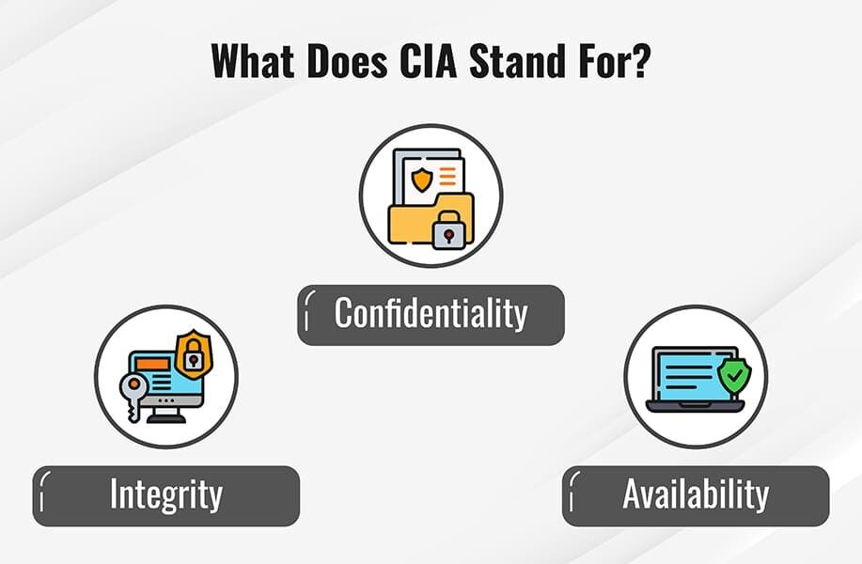

Should You Use The CIA Triad?
The CIA triad provides a simple yet comprehensive high-level checklist for the evaluation of your security procedures and tools. An effective system satisfies all three components: confidentiality, integrity, and availability. An information security system that is lacking in one of the three aspects of the CIA triad is insufficient.
The CIA security triad is also valuable in assessing what went wrong—and what worked—after a negative incident. For example, perhaps availability was compromised after a malware attack such as ransomware, but the systems in place were still able to maintain the confidentiality of important information. This data can be used to address weak points and replicate successful policies and implementations.

When should you use the CIA Triad?
You should use the CIA triad in the majority of security situations, particularly because each component is critical. However, it is particularly helpful when developing systems around data classification and managing permissions and access privileges. You should also stringently employ the CIA triad when addressing the cyber vulnerabilities of your organization. It can be a powerful tool in disrupting the cyber kill chain, especially when combined with threat modeling, which helps security teams map out potential attack paths and assess risk across confidentiality, integrity, and availability. The CIA security triad can help you hone in on what attackers may be after and then implement policies and tools to adequately protect those assets.
In addition, the CIA triad can be used when training employees regarding cybersecurity. You can use hypothetical scenarios or real-life case studies to help employees think in terms of the maintenance of confidentiality, integrity, and availability of information and systems.

Challenges Of Adopting The CIA Triad In Cybersecurity
- Handling massive data: Securing vast amounts of data from numerous sources in multiple formats is challenging for organizations. Duplicate datasets and disaster recovery processes can increase costs and complicate data protection under CIA.
- Weak data stewardship and governance: Big data environments often lack strong auditing and visibility. This leads to poor data stewardship.
- IoT privacy and security gaps: IoT devices transmit fragmented data that can compromise user privacy when aggregated. These devices often go unpatched or use weak passwords. This creates new entry points for cyberattacks.
- Security during product development: Network-connected products should consider security from the design phase to limit attack surfaces. Failing to do so increases risks to sensitive information across interconnected systems.
- Balancing usability and security: Stronger security controls can reduce system availability and frustrate users, leading to workarounds. On the other hand, relaxing security for ease of use can expose systems to breaches.

Implementing The CIA Triad: Best Practices For Cybersecurity
- Categorize and protect sensitive data: Classify all data and assets based on their confidentiality needs. Enforce data encryption, two-factor authentication, and maintain updated access control lists and file permissions as part of essential security hygiene.
- Strengthen role-based privacy training: Conduct regular privacy awareness training for employees. Tailor sessions to both organization-wide privacy standards and role-specific data management requirements.
- Implement data integrity controls: Use version control, data logs, checksums, and hash functions to monitor and preserve data accuracy during processing, transfer, and storage. Apply granular access control to prevent unauthorized data modifications.
- Adhere to the compliance standards: Review regulatory obligations. For instance, under the general data protection regulation (GDPR), ensure that data transfers to third-party vendors meet “adequate levels of protection” and are supported by “legal safeguards.”
- Ensure continuous availability and recovery: Design systems with redundancy and failover mechanisms to reduce downtime. Use network/server monitoring tools and maintain cloud-based backup. This can help ensure quick and complete data recovery and business continuity in case of a security breach.

Enhance Protection With The CIA Triad Principles
Applying the CIA triad can help strengthen an organization’s overall security strategy. It protects sensitive data from exposure, ensures information isn’t tampered with, and keeps systems available when users need them. Together, these three pillars reduce risk, support compliance, and build a robust IT environment.
Organizations should begin by classifying sensitive data and enforcing encryption and access controls to protect confidentiality. Moreover, using the right tools can help maintain data integrity and prevent tampering. Fortinet’s next-generation firewall supports these principles with built-in threat protection, visibility, and uptime. This makes it easier to secure modern, distributed networks.
As the need for safeguarding confidentiality, integrity, and availability grows, traditional firewalls may no longer be sufficient to address the complex security demands. Enhance protection with FortiGate Firewall.

